**ENGLISH WORKSHEET**

**1st GRADE OF PRIMARY SCHOOL**

|  |  |  |
| --- | --- | --- |
| **Student Name** |  | **Grade:** 1st grade |
| **Date:** _____ / _____ /2020 |
| **O.A.(s):** | **OA 13**  Escribir palabras y oraciones simples de acuerdo a un modelo, acerca de temas conocidos. | |

**VOCABULARY: Remember, relate, identify, and match.**

**Family Vocabulary**

 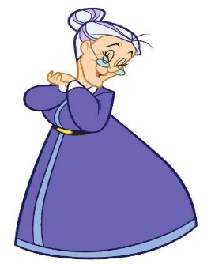

Grandma Grandpa

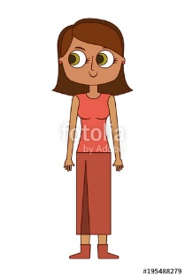



Father Mother



Sister Brother

1. **Trace and Match the following vocabulary. ( *Repasa las letras y luego une según corresponda)***

