**ENGLISH WORKSHEET**

**1st   GRADE OF PRIMARY SCHOOL**

|  |  |  |  |
| --- | --- | --- | --- |
| **Student Name** |  | | **Grade:** 1st grade |
| **Date:** Week 6 |
| **Unit: 1** | *“In my Classroom”* | | |
| **O.A.(s):** | **OA 6** Leer y demostrar comprensión de textos presentados, identificando vocabulario. | | |
| **Objective** | To learn vocabulary about greetings and commands. | | |
| **Teacher:** | **Constanza Caneo Zamora**  **constanza.caneo@colegio-patriciomekis.cl** | **Subject:** | **English** |

**VOCABULARY: Demonstrate, identify, write, and match.**

**Classroom Commands Vocabulary**

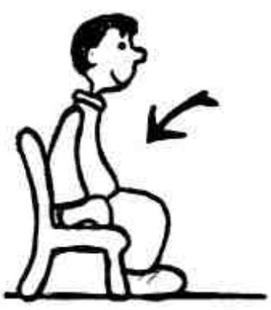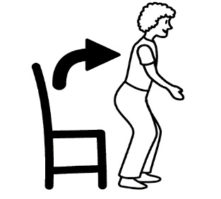

**Stand up Sit down Listen Silence**

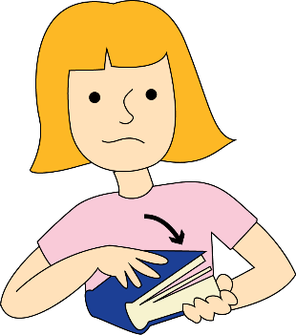



**Clap your hands Open your book Close your book**

**Remember (Recuerda)**

* **Stand up /stand ap/ =** Ponerse de pie
* **Sit down / sit daun/ =** Sentarse
* **Listen /lisen/ =** Escuchar
* **Silence / sailence/ =** Silencio
* **Clap your hands /clap yor jends/=** Aplaudir
* **Open your book /oupen yor buk/ =** Abrir el libro
* **Close your book / clous yor buk/ =** Cerrar el libro



**Nota:** Para complementar el aprendizaje de su hijo, usted puede ingresar al siguiente link:

<https://www.youtube.com/watch?v=vVeMptYOMIg>

