**HOMEWORK**

**1st   GRADE OF PRIMARY SCHOOL**

|  |  |  |  |
| --- | --- | --- | --- |
| **Student Name** |  | | **Grade:** 1st grade |
| **Date:** Week 6 |
| **Unit: 1** | *“In my Classroom”* | | |
| **O.A.(s):** | **OA 6** Leer y demostrar comprensión de textos presentados, identificando vocabulario. | | |
| **Objective** | To learn vocabulary about greetings and commands. | | |
| **Teacher:** | Constanza Caneo Zamora  **constanza.caneo@colegio-patriciomekis.cl** | **Subject:** | English |

1. Color, trace and match the following expressions. (une las imágenes con la palabra, luego repasa las palabras y colorea)

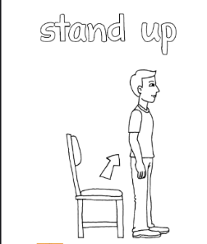



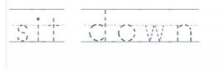







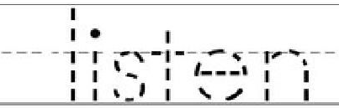



**What did we learn today?**

**¿Qué aprendimos hoy?**



**Circle the correct option (Encierra con un círculo la opción correcta)**

