**ENGLISH WORKSHEET**

**1st   GRADE OF PRIMARY SCHOOL**

|  |  |  |  |
| --- | --- | --- | --- |
| **Student Name** |  | | **Grade:** 1st grade |
| **Date:** Week 7 |
| **Unit: 1** | *“In my Classroom”* | | |
| **O.A.(s):** | **OA 13** Escribir palabras y oraciones simples de acuerdo a un modelo, acerca de temas conocidos. | | |
| **Objective** | To distinguish vocabulary about greetings and commands throughout an English worksheet. | | |
| **Teacher:** | **Constanza Caneo Zamora**  **constanza.caneo@colegio-patriciomekis.cl** | **Subject:** | **English** |

**VOCABULARY: Identify, write, select, and match.**

1. **Look at the pictures and match the word with the correct picture. ( Mira las imágenes y une la palabra con la imagen correcta)**

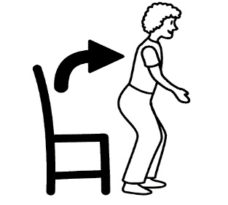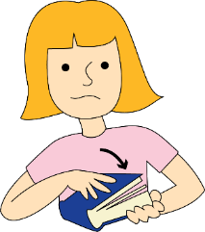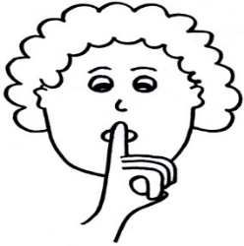

|  |  |  |
| --- | --- | --- |
| **Stand up** | **Silence** | **Close your book** |
| **Clap your hands** | **Sit down** | **Listen** |

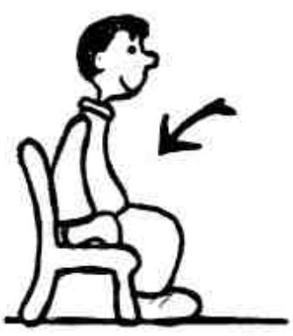

1. **Look at the pictures and color the classroom commands. ( Mira las imágenes y colorea SOLO las reglas de la sala)**

