**ENGLISH WORKSHEET**

**1st   GRADE OF PRIMARY SCHOOL**

|  |  |  |  |
| --- | --- | --- | --- |
| **Student Name** |  | | **Grade:** 1st grade |
| **Date:** Week 8 (25 al 29 /05) |
| **Unit: 1** | *“In my Classroom”* | | |
| **O.A.(s):** | **OA 7** Leer y demostrar comprensión de textos relacionado con temas conocidos: la escuela, seguir y dar instrucciones. | | |
| **Objective** | To review vocabulary about classroom commands throughout an English worksheet. | | |
| **Teacher:** | **Constanza Caneo Zamora**  **constanza.caneo@colegio-patriciomekis.cl** | **Subject:** | **English** |

**VOCABULARY: Read, write, select, demonstrate.**

1. **Look at the pictures and color the correct option (Mira las imágenes y colorea la opción que corresponde)**

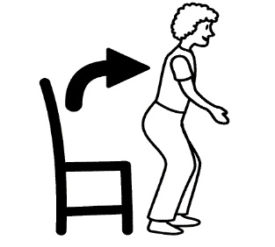

|  |  |
| --- | --- |
| STAND UP | SILENCE |



|  |  |
| --- | --- |
| OPEN YOUR BOOK | LISTEN |

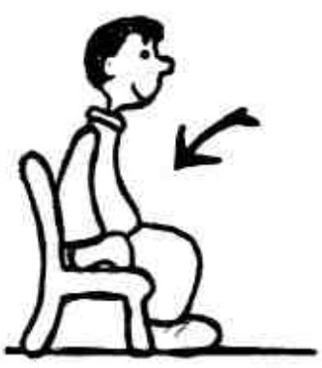

|  |  |
| --- | --- |
| CLOSE YOUR BOOK | SIT DOWN |

|  |  |
| --- | --- |
| CLAP YOUR HANDS | LISTEN |



|  |  |
| --- | --- |
| SILENCE | SIT DOWN |

|  |  |
| --- | --- |
| LISTEN | CLOSE YOUR BOOK |

