**ENGLISH WORKSHEET**

**2nd   GRADE OF PRIMARY SCHOOL**

|  |  |  |  |
| --- | --- | --- | --- |
| **Student Name** |  | | **Grade:** 2nd grade |
| **Date:** Week 4 |
| **Unit: 1** | *“At the Zoo”* | | |
| **O.A.(s):** | **OA 13** Escribir, copiar o completar oraciones simples de acuerdo con un modelo. | | |
| **Objective** | To identify vocabulary related with wild animals. | | |
| **Teacher:** | Constanza Caneo Zamora  **constanza.caneo@colegio-patriciomekis.cl** | **Subject:** | English |

1. Trace the words and then color the pictures. (Repasa las palabras y luego pinta las imágenes).

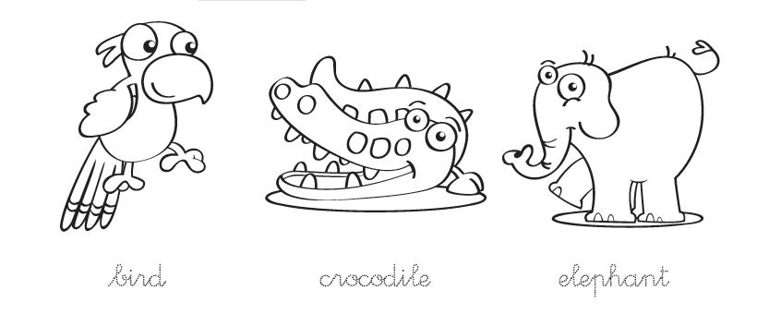

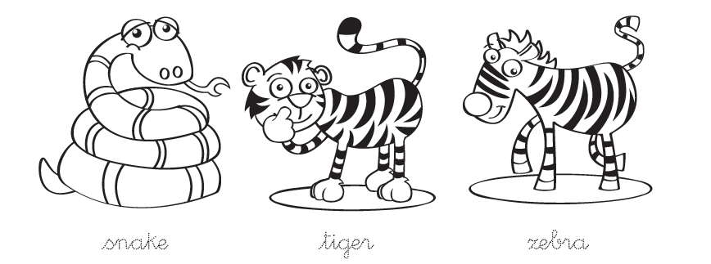

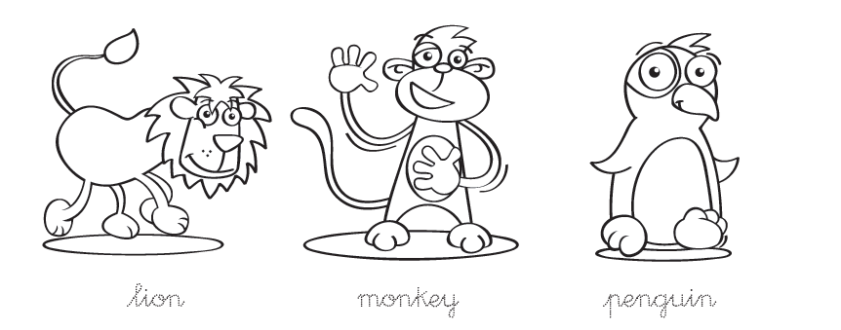

1. **Write the missing letter. *( Escribe la letra que falta para completar la palabra)***

