**ENGLISH WORKSHEET**

**2nd   GRADE OF PRIMARY SCHOOL**

|  |  |  |  |
| --- | --- | --- | --- |
| **Student Name** |  | | **Grade:** 2nd grade |
| **Date:** Week 5 |
| **Unit: 1** | *“At the Zoo”* | | |
| **O.A.(s):** | OA 3 Demostrar comprensión de textos: identificando vocabulario aprendido, animales salvajes. | | |
| **Objective** | To review vocabulary about wild animals. | | |
| **Teacher:** | Constanza Caneo Zamora  **constanza.caneo@colegio-patriciomekis.cl** | **Subject:** | English |

**VOCABULARY: Remember, identify, write, match and demonstrate.**

1. **Look at the pictures and color the correct option (Mira las imágenes y colorea la opción que corresponde).**

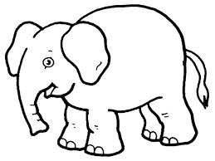

|  |  |
| --- | --- |
| ELEPHANT | TIGER |

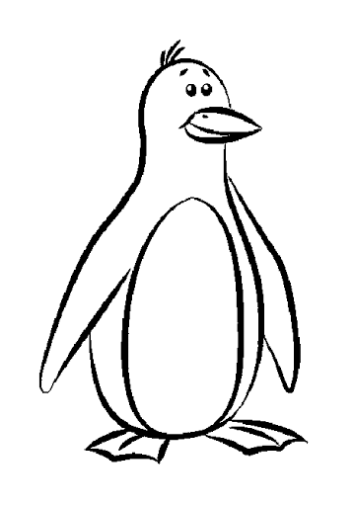

|  |  |
| --- | --- |
| MONKEY | PENGUIN |

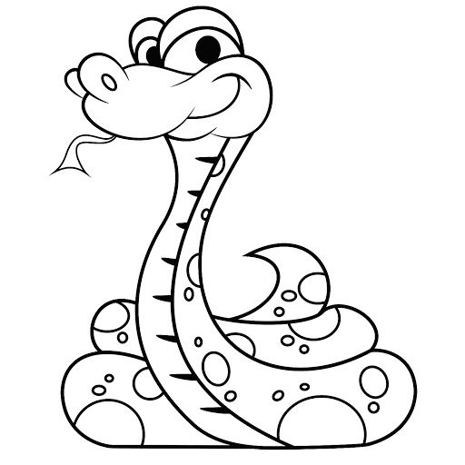

|  |  |
| --- | --- |
| SNAKE | GIRAFFE |



|  |  |
| --- | --- |
| BIRD | MONKEY |

1. **Match, write and color. (Sigue el laberinto y une cada animal con sus respectivas piernas, luego en la línea de más abajo escribe el nombre del animal que corresponde, y finalmente coloréalos).**

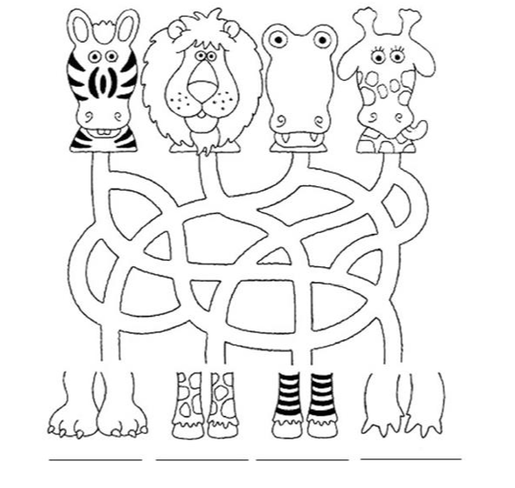



**What did we learn today?**

**¿Qué aprendimos hoy?**

**Circle the correct option (Encierra con un círculo la opción correcta)**

