**ENGLISH WORKSHEET**

**2nd   GRADE OF PRIMARY SCHOOL**

|  |  |  |  |
| --- | --- | --- | --- |
| **Student Name** |  | | **Grade:** 2nd grade |
| **Date:** Week 6 |
| **Unit: 1** | *“At the Zoo”* | | |
| **O.A.(s):** | **OA 6** Leer y demostrar comprensión de textos presentados, identificando vocabulario. | | |
| **Objective** | To learn some actions verbs related with wild animals. | | |
| **Teacher:** | Constanza Caneo Zamora  **constanza.caneo@colegio-patriciomekis.cl** | **Subject:** | English |

**VOCABULARY: Remember, identify, write, match and demonstrate.**

**Action Verbs Vocabulary**

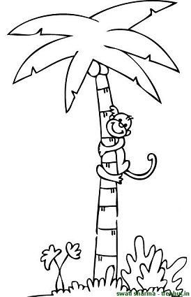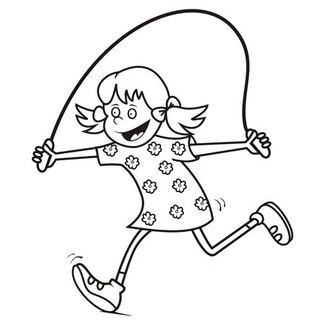

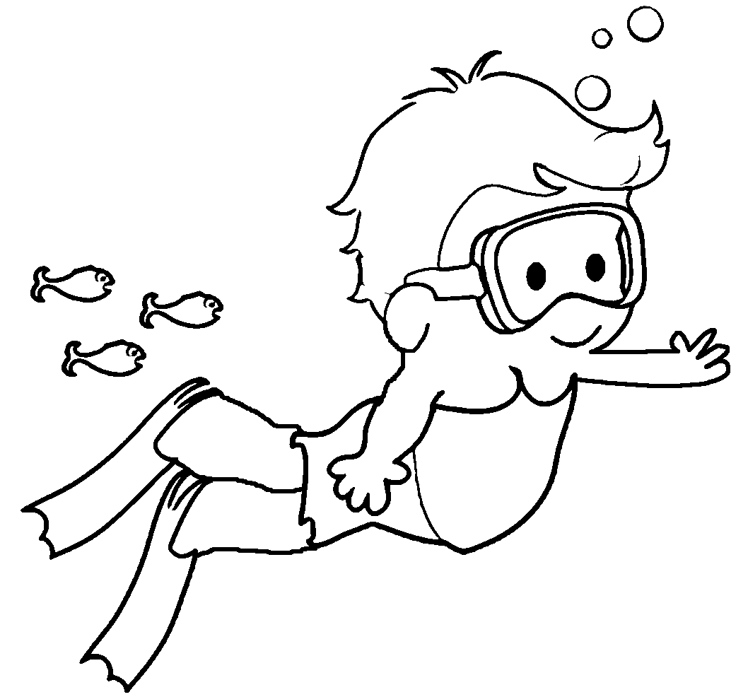

**Climb Jump Swim**

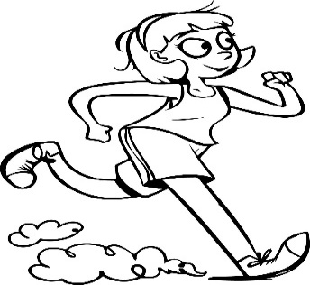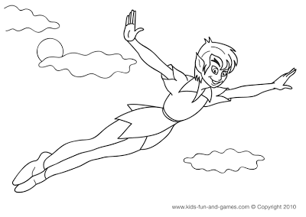

 **Fly Run**

**Remember (Recuerda)**

* **Climb / claim/** = Escalar
* **Jump / yamp/** = Saltar
* **Swim /suim/** = Nadar
* **Fly / flai/** = Volar
* **Run /ruan/** = Correr

**What did we learn today?**

**¿Qué aprendimos hoy?**



**Circle the correct option (Encierra con un círculo la opción correcta)**

