**HOMEWORK**

**2nd   GRADE OF PRIMARY SCHOOL**

|  |  |  |  |
| --- | --- | --- | --- |
| **Student Name** |  | | **Grade:** 2nd grade |
| **Date:** Week 6 |
| **Unit: 1** | *“At the Zoo”* | | |
| **O.A.(s):** | **OA 6** Leer y demostrar comprensión de textos presentados, identificando vocabulario. | | |
| **Objective** | To learn some actions verbs related with wild animals. | | |
| **Teacher:** | Constanza Caneo Zamora  **constanza.caneo@colegio-patriciomekis.cl** | **Subject:** | English |

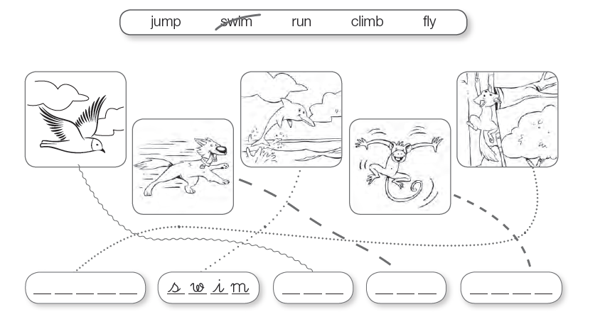

1. **Follow the line and write the correct action. *( sigue la linea y escribe la acción que corresponde)***



_ _ _ _ _ _ _ _ _ _ _ _ _ _ _ _ _ _ _ _ _ _ _ _ _ _ _ _ _ _ _ _ _ _ _ _ _ _ _ _ _ _ _ _ _ _ _ _ _ _ _ _ _ _ _ _ _ _ _ _ _