**ENGLISH WORKSHEET**

**2nd   GRADE OF PRIMARY SCHOOL**

|  |  |  |  |
| --- | --- | --- | --- |
| **Student Name** |  | | **Grade:** 2nd grade |
| **Date:** Week 7 |
| **Unit: 1** | *“At the Zoo”* | | |
| **O.A.(s):** | **OA 7** Leer y demostrar comprensión de textos relacionados con temas conocidos; describir animales y acciones que realizan estos. | | |
| **Objective** | To distinguish some actions verbs related with wild animals. | | |
| **Teacher:** | Constanza Caneo Zamora  **constanza.caneo@colegio-patriciomekis.cl** | **Subject:** | English |

**VOCABULARY: Select, identify, write, match and demonstrate.**

1. **Look at the pictures and match the word with the correct picture. ( Mira las imágenes y une la palabra con la imagen correcta)**

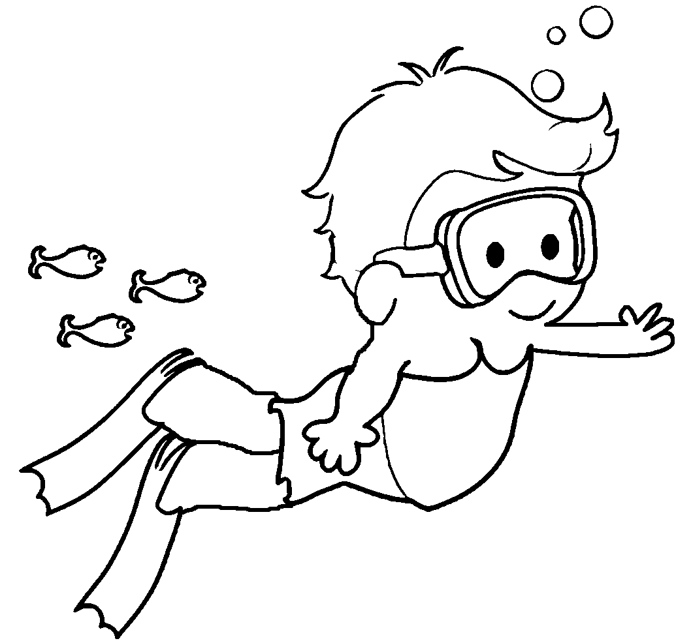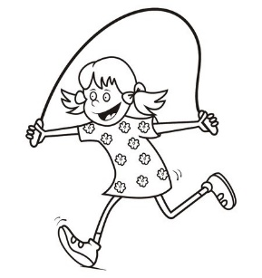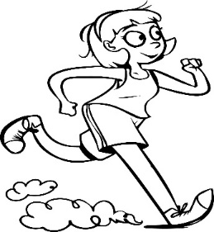

|  |  |  |
| --- | --- | --- |
| **Jump** | **Run** | **Swim** |
| **Climb** | **Fly** |  |

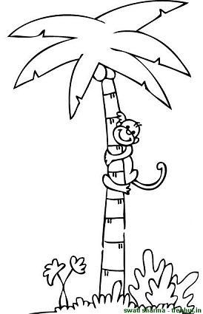

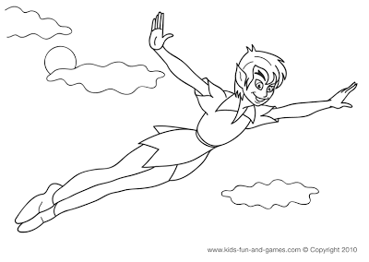

1. **Look at the pictures and color the action verbs related with animals. ( Mira las imágenes y colorea SOLO las acciones que pueden realizar los animales salvajes)**

