**HOMEWORK**

**2nd   GRADE OF PRIMARY SCHOOL**

|  |  |  |  |
| --- | --- | --- | --- |
| **Student Name** |  | | **Grade:** 2nd grade |
| **Date:** Week 8 |
| **Unit: 1** | *“At the Zoo”* | | |
| **O.A.(s):** | **OA 14** Escribir, sobre la base de imágenes para identificar los animales, las acciones y el uso de expresiones. | | |
| **Objective** | To learn the use of can and can´t related with wild animals. | | |
| **Teacher:** | Constanza Caneo Zamora  **constanza.caneo@colegio-patriciomekis.cl** | **Subject:** | English |

1. **Look at the picture and complete the sentences with the correct actions for each animal. ( Mira las imágenes y completa las oraciones con la acciones que pueden o no pueden realizar los animales)**

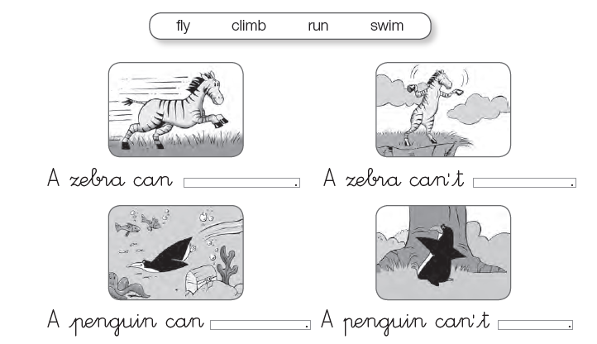

**SOLUCIONARIO ARCHIVO 2**

1. **Look at the pictures and complete the sentence with *CAN* or C*AN’T.* ( Mira las imágenes y completa las oraciones con el uso de can o can’t según corresponde)**

|  |  |  |
| --- | --- | --- |
| **IMAGEN 1** | **IMAGEN 2** | **IMAGEN 3** |
| **CAN’T** | **CAN´T** | **CAN** |

|  |  |  |
| --- | --- | --- |
| **IMAGEN 4** | **IMAGEN 5** | **IMAGEN 6** |
| **CAN’T** | **CAN** | **CAN** |

**SOLUCIONARIO TAREA**

_ _ _ _ _ _ _ _ _ _ _ _ _ _ _ _ _ _ _ _ _ _ _ _ _ _ _ _ _ _ _ _ _ _ _ _ _ _ _ _ _ _ _ _ _ _ _ _ _ _ _ _ _ _ _ _ _ _ _ _ _

1. **Look at the picture and complete the sentences with the correct actions for each animal. ( Mira las imágenes y completa las oraciones con la acciones que pueden o no pueden realizar los animales)**

|  |  |
| --- | --- |
| **IMAGEN 1** | **IMAGEN 2** |
| **RUN** | **FLY** |

|  |  |
| --- | --- |
| **IMAGEN 3** | **IMAGEN 4** |
| **SWIM** | **CLIMB** |