**ENGLISH WORKSHEET**

**3rd  GRADE OF PRIMARY SCHOOL**

|  |  |  |
| --- | --- | --- |
| **Student Name** |  | **Grade:** 3rd grade |
| **Date:** _____ / _____ /2020 |
| **O.A.(s):** | **OA 13** Escribir palabras y oraciones simples de acuerdo a un modelo, acerca de temas conocidos | |

**VOCABULARY: Remember, identify, write, and match.**

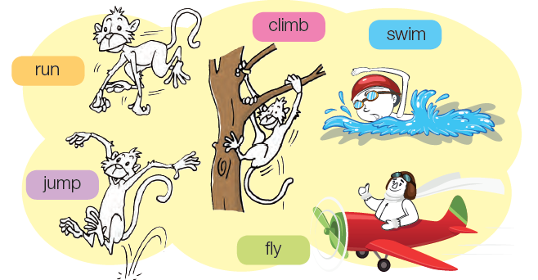

|  |
| --- |
| **Vocabulary**   * **Run:** Correr * **Jump:** Saltar * **Climb:** Escalar * **Swim:** Nadar * **Fly:** Volar |

1. **Follow the line and write the correct action. *( sigue la linea y escribe la accion que corresponde)***

