**ENGLISH WORKSHEET**

**3rd    GRADE OF PRIMARY SCHOOL**

|  |  |  |  |
| --- | --- | --- | --- |
| **Student Name** |  | | **Grade:** 3rd grade |
| **Date:** Week 5 |
| **Unit: 1** | *“My clothes”* | | |
| **O.A.(s):** | **OA 7 Leer y demonstrar comprensión de textos relacionados con temas conocidos.** | | |
| **Objective** | To learn vocabulary about clothes. | | |
| **Teacher:** | Constanza Caneo Zamora  **constanza.caneo@colegio-patriciomekis.cl** | **Subject:** | English |

**VOCABULARY: Demonstrate, identify, write, and match.**

**Clothes Vocabulary**

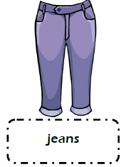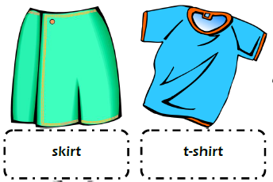

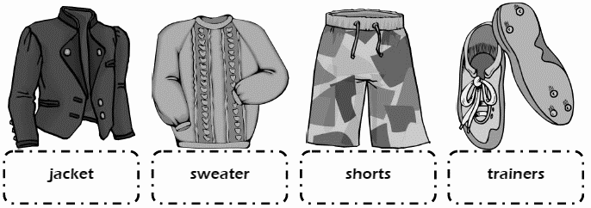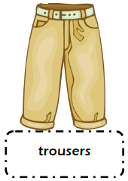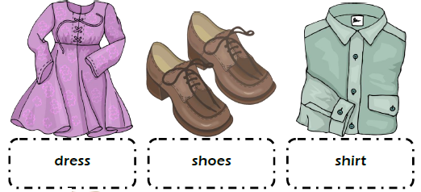

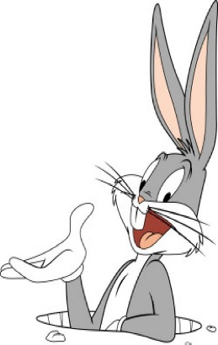

**Remember (Recuerda)**

* **Skirt /skert**/ = Falda
* **T-shirt / tishert/** = Polera
* **Jeans / yins/ =** Jeans o Pantalones
* **Dress /dres/ =** Vestido
* **Shoes / shus/** = Zapatos
* **Shirt / shert**/ = Camisa
* **Trousers / trausers/ =** Pantalones
* **Jacket / yakit/ =** Chaqueta
* **Sweater / suerer/** = Suéter o chaleco
* **Shorts / shorts/ =** Pantalones cortos
* **Trainers / treiner/** = Zapatillas
* **.**

**Nota:** Para complementar el aprendizaje de su hijo, usted puede ingresar los siguientes links:

[**https://www.youtube.com/watch?v=PKOVLKo3Z9M**](https://www.youtube.com/watch?v=PKOVLKo3Z9M)

[**https://www.youtube.com/watch?v=pHer1COWyrQ**](https://www.youtube.com/watch?v=pHer1COWyrQ)



**Exercises**

1. **Write the name of the following clothes. ( Mira las imágenes y escribe el nombre de la vestimenta según corresponde)**

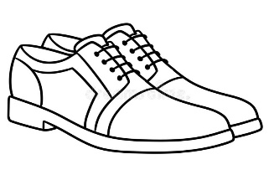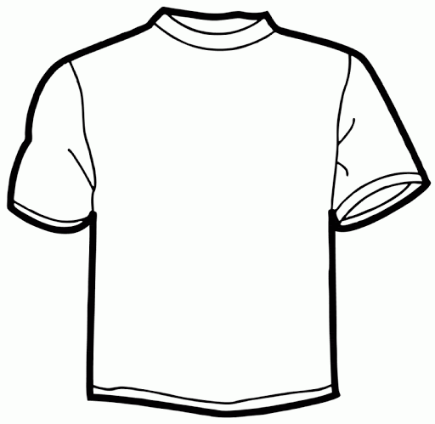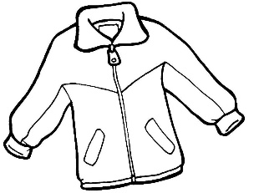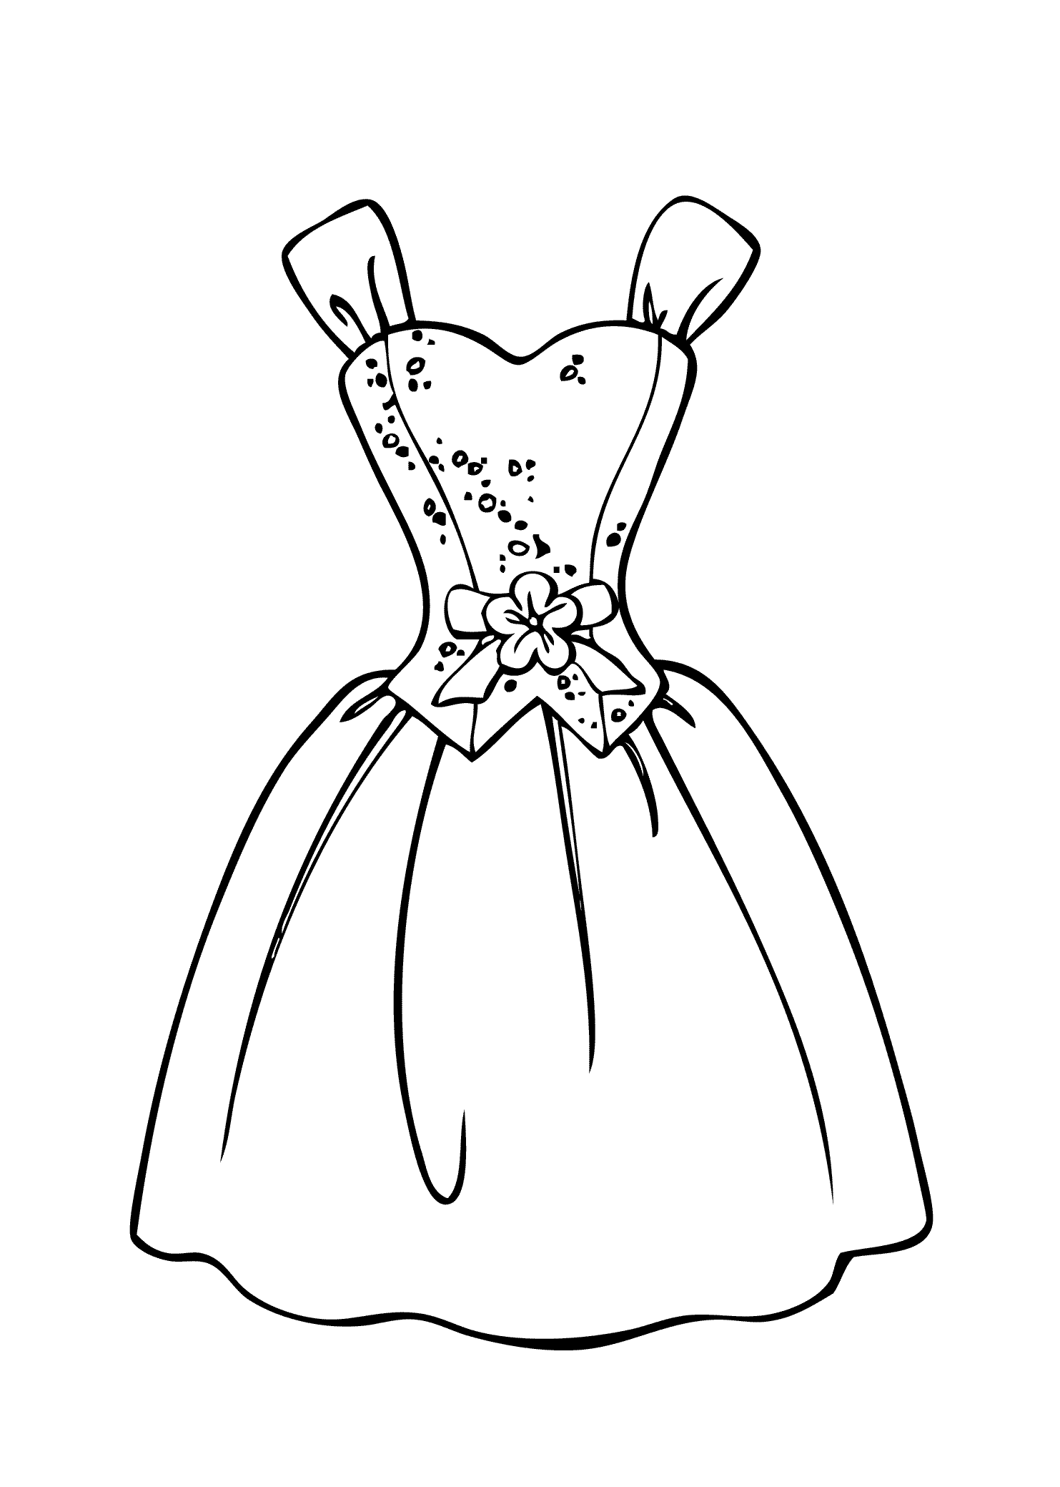

_________________ ________________ _________________ ____________________



**What did we learn today?**

**¿Qué aprendimos hoy?**

**Circle the correct option (Encierra con un círculo la opción correcta)**

