**HOMEWORK**

**3rd    GRADE OF PRIMARY SCHOOL**

|  |  |  |  |
| --- | --- | --- | --- |
| **Student Name** |  | | **Grade:** 3rd grade |
| **Date:** Week 5 |
| **Unit: 1** | *“My clothes”* | | |
| **O.A.(s):** | **OA 7 Leer y demonstrar comprensión de textos relacionados con temas conocidos.** | | |
| **Objective** | **To learn vocabulary about clothes.** | | |
| **Teacher:** | Constanza Caneo Zamora  **constanza.caneo@colegio-patriciomekis.cl** | **Subject:** | English |

1. 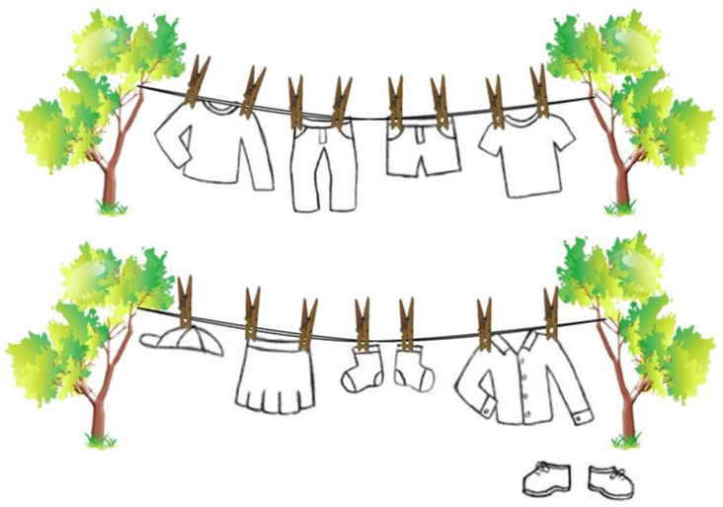**Follow the instructions and paint with the correct color. ( Lee las instrucciones que te indica la tabla de más abajo, identifica y luego pinta la vestimenta según el color que esta te indica , el color que debes pintar la ropa esta escrito en *cursiva*)**

|  |  |
| --- | --- |
| Colour the t-shirt *blue.* | Colour the socks *green.* |
| Colour the skirt *pink*. | Colour the trousers *yellow.* |
| Colour the sweater *red.* | Colour the shirt *purple.* |
| Colour the shoes *orange.* | Colour the hat *black.* |
| Colour the shorts *white.* |  |

* **Socks = calcetines**
* **Hat = gorro**