**ENGLISH WORKSHEET**

**3rd    GRADE OF PRIMARY SCHOOL**

|  |  |  |  |
| --- | --- | --- | --- |
| **Student Name** |  | | **Grade:** 3rd grade |
| **Date:** Week 6 |
| **Unit: 1** | *“My clothes”* | | |
| **O.A.(s):** | **OA 6** Leer y demostrar comprensión de textos presentados identificando vocabulario. | | |
| **Objective** | To identify vocabulary about clothes. | | |
| **Teacher:** | Constanza Caneo Zamora  **constanza.caneo@colegio-patriciomekis.cl** | **Subject:** | English |

**VOCABULARY: Demonstrate, identify, write, and match.**

1. 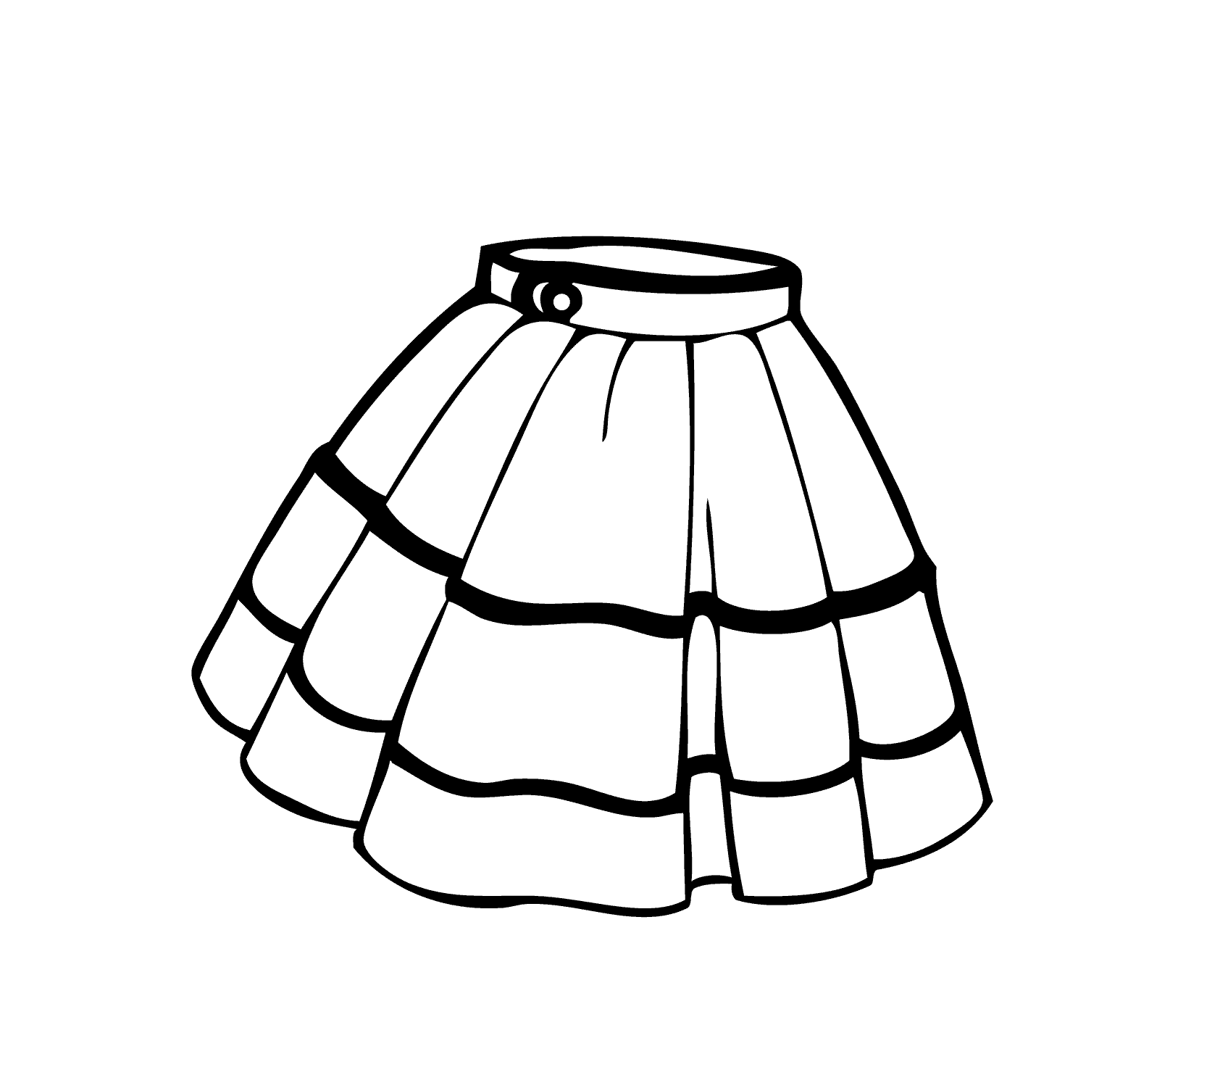**Write the name of the following clothes. ( Mira las imágenes y escribe el nombre de la vestimenta según corresponde)**

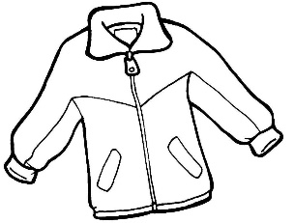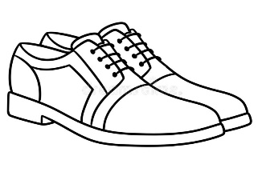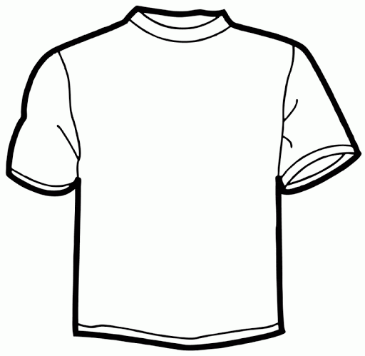

_________________ ________________ _________________ ____________________

1. **Write the missing letter in order to complete the following words. ( Escribe la letra que falta para completar las palabras)**
2. **SK__RT 5. TR__USER__**

1. **JE__NS 6. SH__RTS**
2. **DR__SS 7. JAC__ET**
3. **SH__ES 8. TRA__NER__**
4. **Look at the pictures and choose the correct option. ( Mira las imágenes y marca la opción que corresponde)**

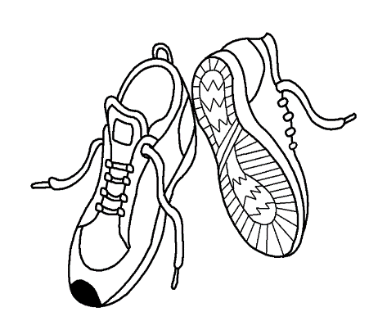

|  |
| --- |
| 1. **Jeans** |
| 1. **Trainers** |
| 1. **Dress** |

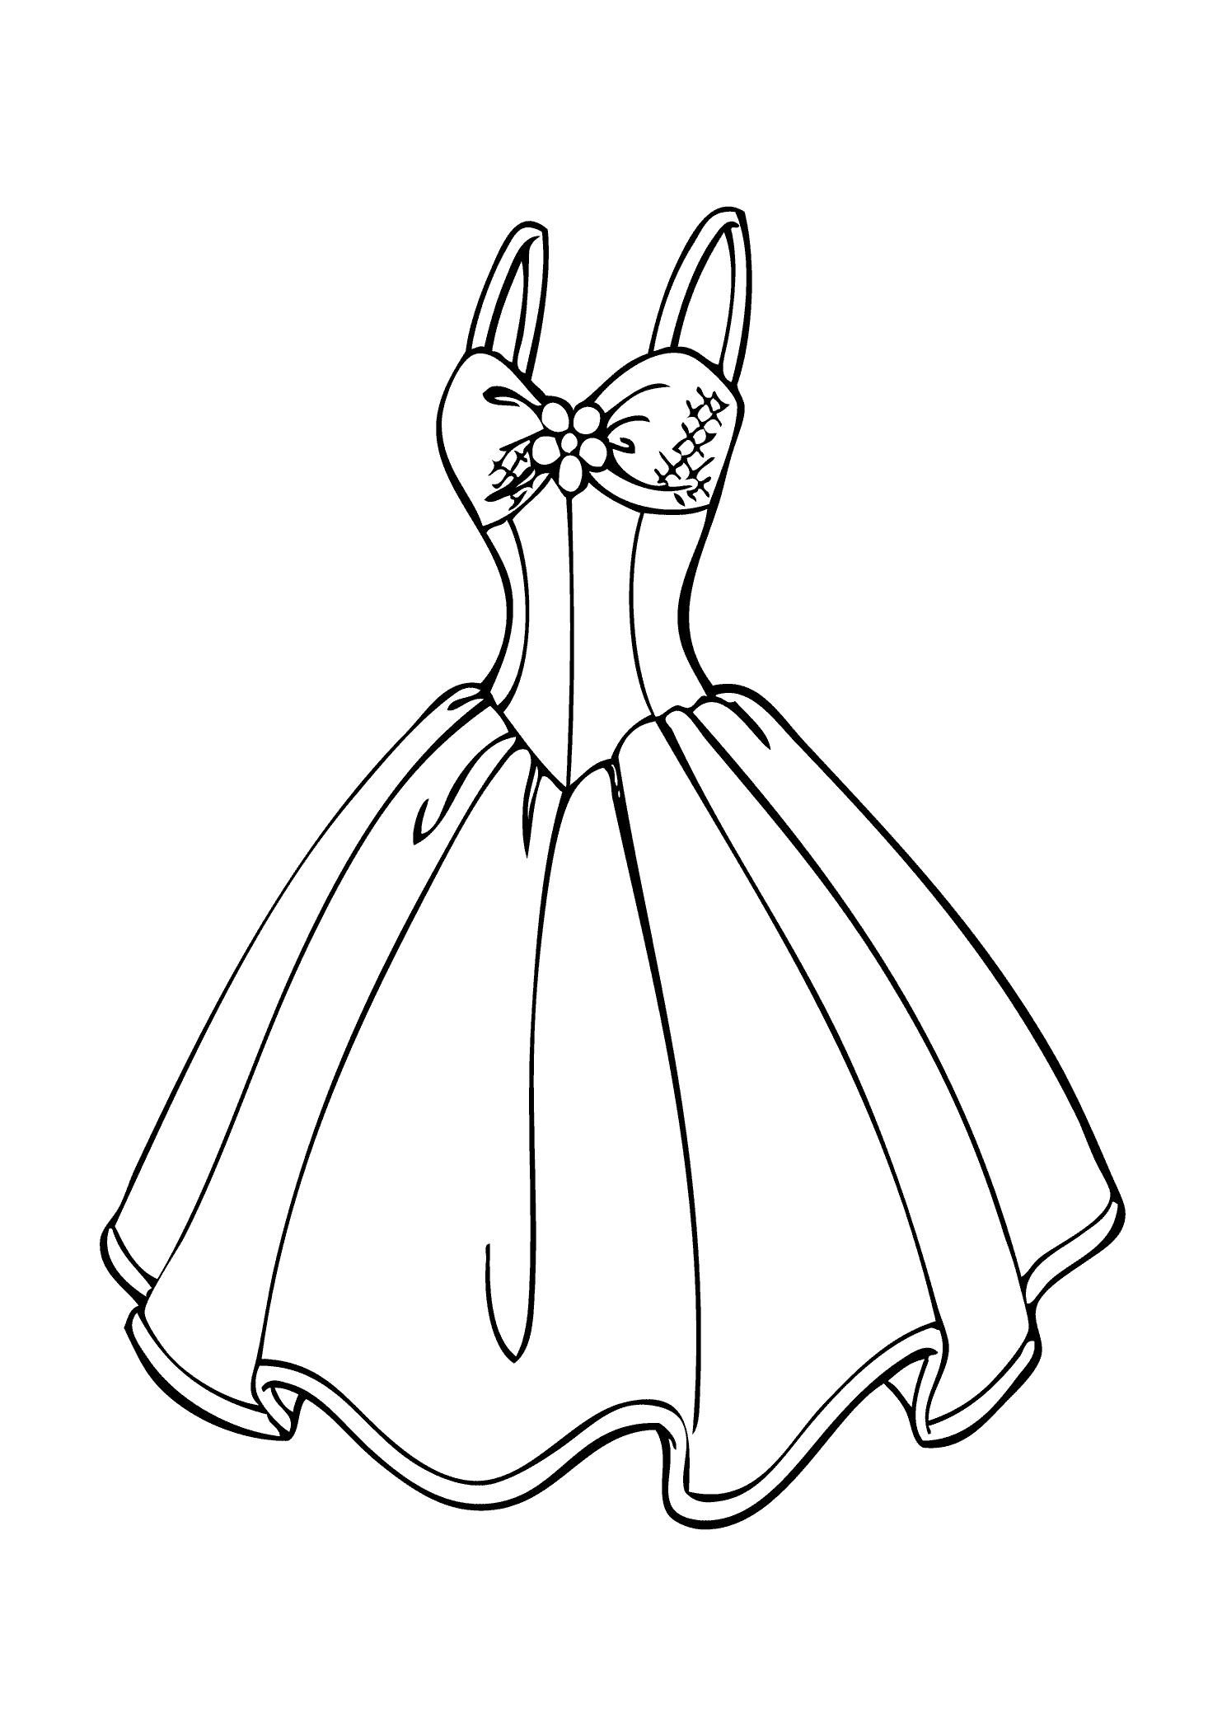

|  |
| --- |
| 1. **Trousers** |
| 1. **Shorts** |
| 1. **Dress** |

|  |
| --- |
| 1. **Sweater** |
| 1. **T- shirt** |
| 1. **Skirt** |

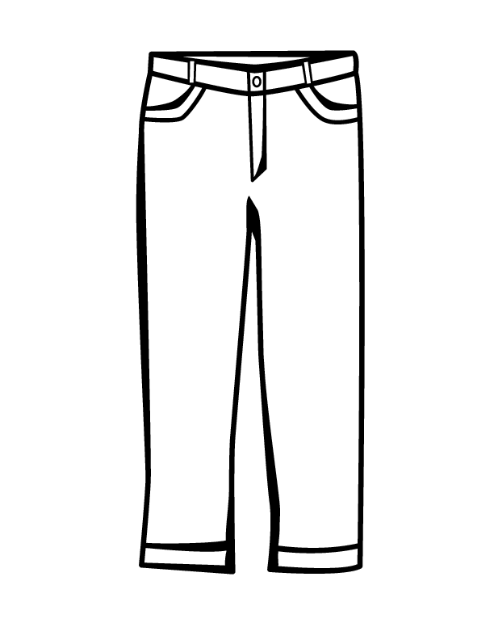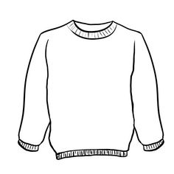

|  |
| --- |
| 1. **Shoes** |
| 1. **Jeans** |
| 1. **Dress** |