**ENGLISH WORKSHEET**

**4th    GRADE OF PRIMARY SCHOOL**

|  |  |  |  |
| --- | --- | --- | --- |
| **Student Name** |  | | **Grade:** 4th grade |
| **Date:** Week 5 |
| **Unit: 1** | *“How do you feel?”* | | |
| **O.A.(s):** | OA 6 Leer y demostrar comprensión de textos identificando vocabulario aprendido y palabras conocidas. | | |
| **Objective** | To recognize vocabulary about illnesses and Health problems. | | |
| **Teacher:** | Constanza Caneo Zamora  **constanza.caneo@colegio-patriciomekis.cl** | **Subject:** | English |

**VOCABULARY: Remember, identify, write, and match.**

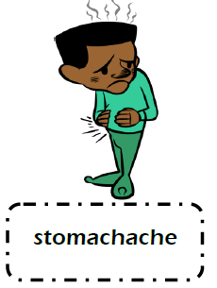**Illnesses Vocabulary**

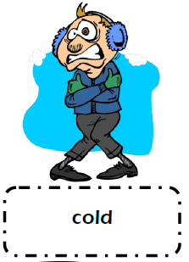

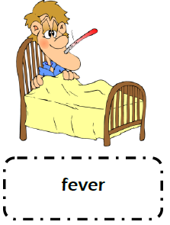



**Remember (Recuerda)**

* **Headache /hedeik/** = Dolor de cabeza
* **Stomachache / stomakeik/** = Dolor de estómago
* **Toothache /tuzeik/** = Dolor de muelas
* **Sore throat /sor zrout/** = Dolor de garganta
* **Earache /ireik/** = Dolor de oídos
* **Fever / fiver/** = Fiebre
* **Cold /could/ =** Resfriado
* **Cough / cof/** = Tos

**Nota:** Para complementar el aprendizaje de su hijo, usted puede ingresar al siguiente link:

<https://www.youtube.com/watch?v=JFC0qG-gGaw&t=34s>





**What did we learn today?**

**¿Qué aprendimos hoy?**

**Circle the correct option (Encierra con un círculo la opción correcta)**

