**HOMEWORK**

**4th    GRADE OF PRIMARY SCHOOL**

|  |  |  |  |
| --- | --- | --- | --- |
| **Student Name** |  | | **Grade:** 4th grade |
| **Date:** Week 5 |
| **Unit: 1** | *“How do you feel?”* | | |
| **O.A.(s):** | OA 6 Leer y demostrar comprensión de textos identificando vocabulario aprendido y palabras conocidas. | | |
| **Objective** | To recognize vocabulary about illnesses and Health problems. | | |
| **Teacher:** | Constanza Caneo Zamora  **constanza.caneo@colegio-patriciomekis.cl** | **Subject:** | English |

1. **Look at the pictures and write the name of the following illnesses. (Mira las imágenes y escribe el nombre de las enfermedades).**

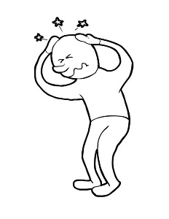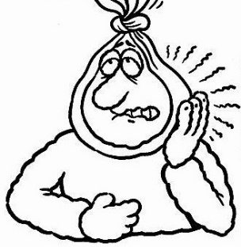



**___________________ _________________ ____________________ _________________**

1. **Write the missing letter. (Escribe la letra que falta para completar la palabra).**

**H__AD__ACH__ F__VE__**

**ST__MAC__ACH__ C__LD**

**T__OTH__CH__ C__UGH**

**SORE __HROA__ E__RAC__E**

1. **Find and circle the ILLNESSES in the word search puzzle. *( Busca las palabras que están en el cuadro en la siguiente sopa de letras)***

|  |  |  |  |  |  |  |  |  |  |
| --- | --- | --- | --- | --- | --- | --- | --- | --- | --- |
| H | E | A | D | A | C | H | E | W | Q |
| O | Z | C | B | L | I | U | D | H | L |
| S | W | P | F | X | Y | I | C | U | L |
| S | O | R | E | T | H | R | O | A | T |
| F | V | J | V | S | I | K | L | T | W |
| H | X | I | E | Q | R | B | D | C | P |
| L | G | E | R | P | I | S | L | O | Y |
| Z | I | S | K | M | R | A | I | U | L |
| E | A | R | A | C | H | E | W | G | Z |
| Y | T | O | O | T | H | A | C | H | E |

**HEADACHE**

**TOOTHACHE**

**SORE THROAT**

**EARACHE**

**FEVER**

**COLD**

**COUGH**

1. **Choose the correct option. (Mira la imagen y elige la opción que corresponde)**

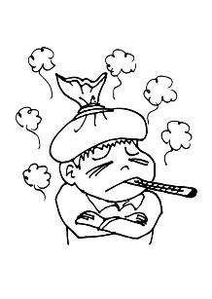

|  |
| --- |
| 1. **STOMACHACHE** |
| 1. **FEVER** |
| 1. **EARACHE** |



|  |
| --- |
| 1. **HEADACHE** |
| 1. **COUGH** |
| 1. **SORE THROAT** |

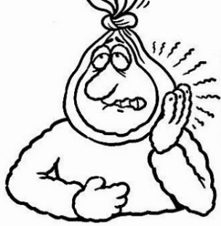

|  |
| --- |
| 1. **STOMACHACHE** |
| 1. **HEADACHE** |
| 1. **TOOTHACHE** |

**SOLUCIONARIO**

1. **Look at the pictures and write the name of the following illnesses. (Mira las imágenes y escribe el nombre de las enfermedades).**

|  |  |  |  |
| --- | --- | --- | --- |
| **IMAGEN 1** | **IMAGEN 2** | **IMAGEN 3** | **IMAGEN 4** |
| STOMACHACHE | EARACHE | TOOTHACHE | HEADACHE |

1. **Write the missing letter. (Escribe la letra que falta para completar la palabra).**

|  |  |
| --- | --- |
| HEADACHE | FEVER |
| STOMACHACHE | COLD |
| TOOTHACHE | COUGH |
| SORE THROAT | EARACHE |

1. **Find and circle the ILLNESSES in the word search puzzle. *( Busca las palabras que están en el cuadro en la siguiente sopa de letras)***

|  |  |  |  |  |  |  |  |  |  |
| --- | --- | --- | --- | --- | --- | --- | --- | --- | --- |
| H | E | A | D | A | C | H | E | W | Q |
| O | Z | C | B | L | I | U | D | H | L |
| S | W | P | F | X | Y | I | C | U | L |
| S | O | R | E | T | H | R | O | A | T |
| F | V | J | V | S | I | K | L | T | W |
| H | X | I | E | Q | R | B | D | C | P |
| L | G | E | R | P | I | S | L | O | Y |
| Z | I | S | K | M | R | A | I | U | L |
| E | A | R | A | C | H | E | W | G | Z |
| Y | T | O | O | T | H | A | C | H | E |

1. **Choose the correct option. (Mira la imagen y elige la opción que corresponde)**

|  |  |
| --- | --- |
| **IMAGEN 1** | **B** |
| **IMAGEN 2** | **A** |
| **IMAGEN 3** | **C** |