**ENGLISH WORKSHEET**

**4th    GRADE OF PRIMARY SCHOOL**

|  |  |  |  |
| --- | --- | --- | --- |
| **Student Name** |  | | **Grade:** 4th grade |
| **Date:** Week 6 |
| **Unit: 1** | *“How do you feel?”* | | |
| **O.A.(s):** | **OA 7** Leer y demostrar comprensión de textos relacionado con temas conocidos. | | |
| **Objective** | To identify vocabulary about illnesses and Health problems through some exercises. | | |
| **Teacher:** | Constanza Caneo Zamora  **constanza.caneo@colegio-patriciomekis.cl** | **Subject:** | English |

**VOCABULARY: Remember, identify, write, and match.**

1. **Match the following pictures. ( Une las siguientes imagenes con la palabra que corresponde).**

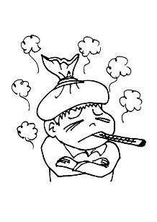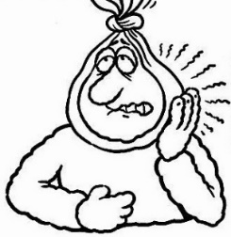

|  |  |  |  |  |
| --- | --- | --- | --- | --- |
| EARACHE | STOMACHACHE | TOOTHACHE | FEVER | HEADACHE |

1. **Unscramble the following words and write the spanish meaning. ( Ordena las siguientes palabras y escribe su significado en español).**

|  |  |  |
| --- | --- | --- |
| **WORD** (palabra desoredena) | **Unscramble** (palabra ordenada) | **Spanish** ( Español) |
| **achehead** |  |  |
| **achetooth** |  |  |
| **verfe** |  |  |
| **achestomach** |  |  |
| **oughco** |  |  |

**Solucionario**

1. **Match the following pictures. ( Une las siguientes imagenes con la palabra que corresponde).**

|  |  |
| --- | --- |
| **IMAGEN 1** | **TOOTHACHE** |
| **IMAGEN 2** | **FEVER** |
| **IMAGEN 3** | **HEADACHE** |
| **IMAGEN 4** | **STOMACHACHE** |
| **IMAGEN 5** | **EARACHE** |

1. **Unscramble the following words and write the spanish meaning. ( Ordena las siguientes palabras y escribe su significado en español).**

|  |  |  |
| --- | --- | --- |
| **WORD** (palabra desoredena) | **Unscramble** (palabra ordenada) | **Spanish** ( Español) |
| **achehead** | ***HEADACHE*** | ***Dolor de cabeza*** |
| **achetooth** | ***TOOTHACHE*** | ***Dolor de muela*** |
| **verfe** | ***FEVER*** | ***Fiebre*** |
| **achestomach** | ***STOMACHACHE*** | ***Dolor de estómago*** |
| **oughco** | ***COUGH*** | ***Tos*** |