**ENGLISH WORKSHEET**

**4th    GRADE OF PRIMARY SCHOOL**

|  |  |  |  |
| --- | --- | --- | --- |
| **Student Name** |  | | **Grade:** 4th grade |
| **Date:** Week 8 |
| **Unit: 1** | *“How do you feel?”* | | |
| **O.A.(s):** | **OA 14** Escribir, sobre la base de imágenes, para: identificar las acciones a considerar para las enfermedades**.** | | |
| **Objective** | To learn actions related to illnesses. | | |
| **Teacher:** | Constanza Caneo Zamora  **constanza.caneo@colegio-patriciomekis.cl** | **Subject:** | English |

**VOCABULARY: Demonstrate, identify, write, and match.**

**Actions related to Illnesses**

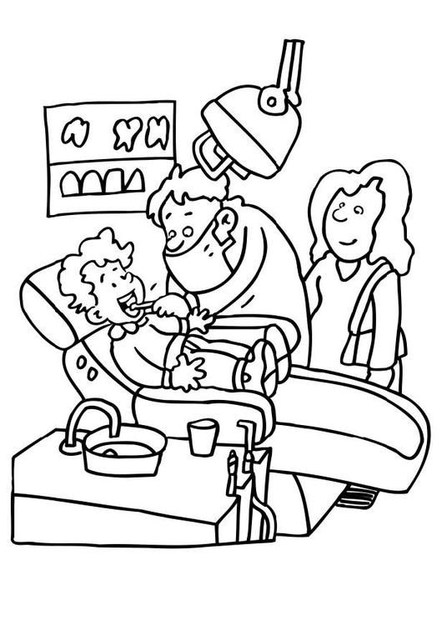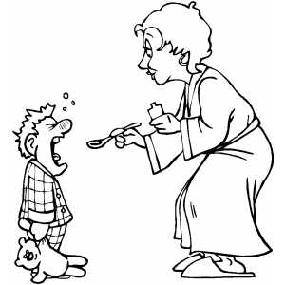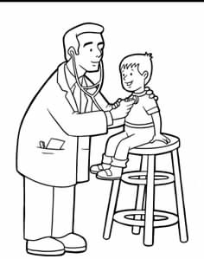

**Take some medicine Go to the doctor Go to the dentist**

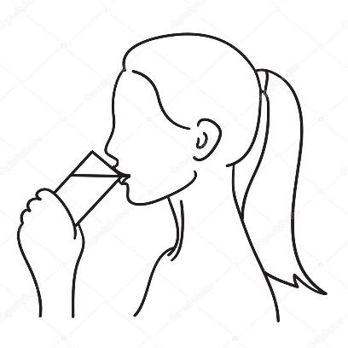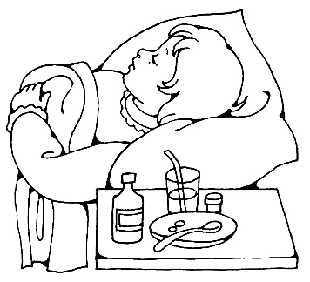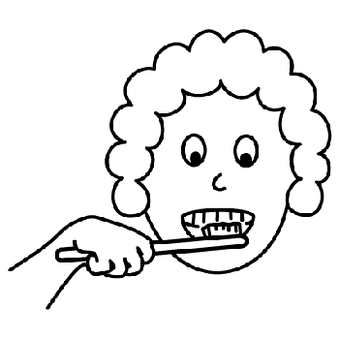

**Drink water Brush your teeth Go to bed / Rest**



**Remember (Recuerda)**

* **Take some medicine / teik som medisin/** = Tomar o ingerir un remedio
* **Go to the doctor / gou tu de doctor/ =** Ir al doctor.
* **Go to the dentist / gou tu de dentist/ =** Ir al dentist.
* **Drink water /drink guater/ =** Beber o tomar agua.
* **Brush your teeth /brash yor tiiz**/ = Lavarse o cepillarse los dientes.
* **Go to bed / gou tu bed/ =** Ir a descansar

**Let’s Practice**

1. **Look at the pictures and write the correct name. (Mira las imágenes y escribe el nombre de las siguientes acciones).**



 

