**HOMEWORK**

**4th    GRADE OF PRIMARY SCHOOL**

|  |  |  |  |
| --- | --- | --- | --- |
| **Student Name** |  | | **Grade:** 4th grade |
| **Date:** Week 8 |
| **Unit: 1** | *“How do you feel?”* | | |
| **O.A.(s):** | **OA 14** Escribir, sobre la base de imágenes, para: identificar las acciones a considerar para las enfermedades**.** | | |
| **Objective** | To learn actions related to illnesses. | | |
| **Teacher:** | Constanza Caneo Zamora  **constanza.caneo@colegio-patriciomekis.cl** | **Subject:** | English |

1. **Match the pictures with the correct phrase. (Une la imagen con la frase que corresponde).**

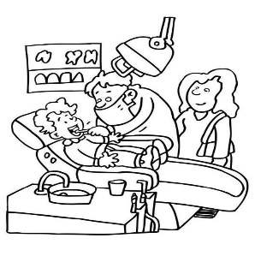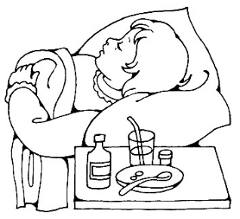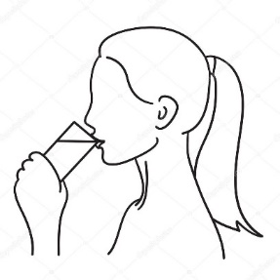

|  |  |  |
| --- | --- | --- |
| Go to bed | Drink water | Go to the dentist |
| Brush your teeth | Go to the doctor | Take some medicine |

