**ENGLISH WORKSHEET**

**5th   GRADE OF PRIMARY SCHOOL**

|  |  |  |
| --- | --- | --- |
| **Student Name** |  | **Grade:** 5th grade |
| **Date:** _____ / _____ /2020 |
| **O.A.(s):** | **OA 13** Demostrar conocimiento y uso del vocabulario aprendido:  › vocabulario temático de uso cotidiano  › palabras de uso frecuente | |

**VOCABULARY: Remember, identify, write, and match.**

1. **Choose the correct words from the list below and writhe them in the correct boxes.**

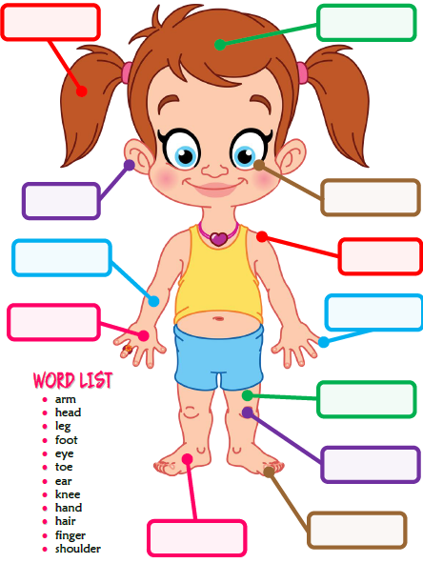

1. **Match the following words with the correct part of the body*. (Une las partes del cuerpo según corresponda.)***

