**ENGLISH WORKSHEET**

**5th   GRADE OF PRIMARY SCHOOL**

|  |  |  |  |
| --- | --- | --- | --- |
| **Student Name** |  | | **Grade:** 5th grade |
| **Date:** Week 5 |
| **Unit: 1** | *“My World”* | | |
| **O.A.(s):** | **OA 5** Leer y demostrar comprensión de textos simples, que contengan palabras de uso frecuente, para identificar, objetos, lugares, familia, asignaturas del colegio. | | |
| **Objective** | To recognize vocabulary about school subjects through and English worksheet. | | |
| **Teacher:** | Constanza Caneo Zamora  **constanza.caneo@colegio-patriciomekis.cl** | **Subject:** | English |

**VOCABULARY: Demonstrate, identify, write, and match.**

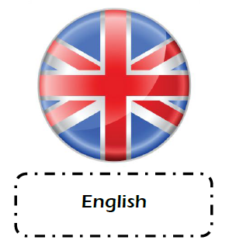**School Subjects Vocabulary**

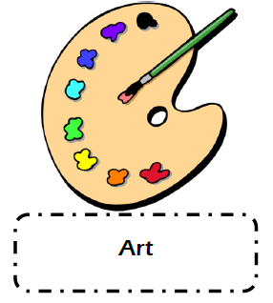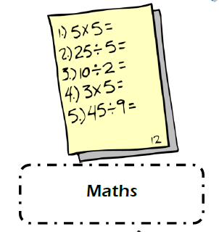



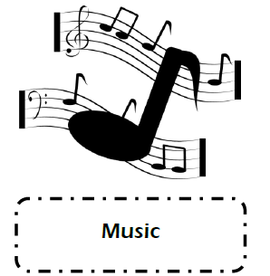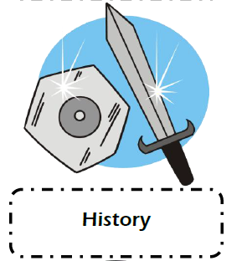

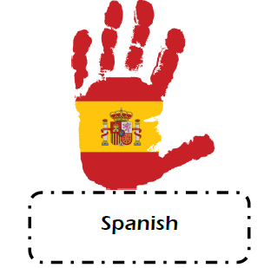



**Remember (Recuerda)**

* **Math / maz/ =** Matemática
* **English /inglish/** = Inglés
* **Science / saiens/** = Ciencias
* **Art /art/** = Artes Visuales
* **History /jisteri/** = Historia
* **Music / miusic/** = Música
* **Physical Education / fisical edukeishion/** = Educación Física
* **Information Technology / Informeishion Tecnoloyi**/ = Computación
* **Spanish /spanish/** = Español o Lenguaje

**Nota:** Para complementar el aprendizaje de su hijo, usted puede ingresar al siguiente link:

<https://www.youtube.com/watch?v=AnZxeX_8mVk>





**What did we learn today?**

**¿Qué aprendimos hoy?**

**Write with your own words what we learned in this class and give an example (Escribe con tus propias palabras lo que estudiamos hoy y da un ejemplo, este último escríbelo en inglés)**

**________________________________________________________________________________________________________________________________________________________________________________________________________________________________________________**