**ENGLISH WORKSHEET**

**5th   GRADE OF PRIMARY SCHOOL**

|  |  |  |  |
| --- | --- | --- | --- |
| **Student Name** |  | | **Grade:** 5th grade |
| **Date:** Week 6 |
| **Unit: 1** | *“My World”* | | |
| **O.A.(s):** | **OA 6** Leer comprensivamente textos no literarios, como notas, postales, invitaciones, sopas de letras para identificar vocabulario aprendido. | | |
| **Objective** | To identify vocabulary about school subjects through and English worksheet. | | |
| **Teacher:** | Constanza Caneo Zamora  **constanza.caneo@colegio-patriciomekis.cl** | **Subject:** | English |

**VOCABULARY: Demonstrate, identify, write, and match.**

1. **Match the following pictures. ( Une las siguientes imagenes con la palabra que corresponde).**

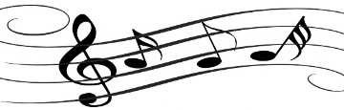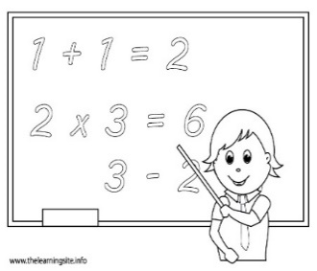

|  |  |  |  |
| --- | --- | --- | --- |
| **SCIENCE** | **INFORMATION TECHNOLOGY** | **MATH** | **MUSIC** |

1. **Find and circle the school subjectsin the word seach puzzle ( Busca las palabras que están en eñ cuadro en la siguiente sopa de letras)**

|  |  |  |  |  |  |  |  |  |  |
| --- | --- | --- | --- | --- | --- | --- | --- | --- | --- |
| H | M | F | S | C | I | E | N | C | E |
| I | K | G | Z | R | T | S | X | Z | I |
| S | L | Y | X | A | R | T | I | O | S |
| T | P | U | N | G | F | J | C | V | P |
| O | I | I | B | N | M | Y | A | J | A |
| R | F | S | V | T | K | U | S | M | N |
| Y | U | M | U | S | I | C | L | N | I |
| A | G | Q | X | D | F | T | P | O | S |
| S | T | T | E | N | G | L | I | S | H |
| Y | W | E | R | Q | L | P | C | V | W |

**History**

**English**

**Spanish**

**Art**

**Science**

**Music**

**Solucionario**

1. **Match the following pictures.**

|  |  |  |  |
| --- | --- | --- | --- |
| **IMAGEN 1** | **IMAGEN 2** | **IMAGEN 3** | **IMAGEN 4** |
| **MATH** | **MUSIC** | **INFORMATION TECHNOLOGY** | **SCIENCE** |

1. **Find and circle the school subjectsin the word seach puzzle**

|  |  |  |  |  |  |  |  |  |  |
| --- | --- | --- | --- | --- | --- | --- | --- | --- | --- |
| H | M | F | S | C | I | E | N | C | E |
| I | K | G | Z | R | T | S | X | Z | I |
| S | L | Y | X | A | R | T | I | O | S |
| T | P | U | N | G | F | J | C | V | P |
| O | I | I | B | N | M | Y | A | J | A |
| R | F | S | V | T | K | U | S | M | N |
| Y | U | M | U | S | I | C | L | N | I |
| A | G | Q | X | D | F | T | P | O | S |
| S | T | T | E | N | G | L | I | S | H |
| Y | W | E | R | Q | L | P | C | V | W |