**HOMEWORK**

**6th   GRADE OF PRIMARY SCHOOL**

|  |  |  |  |
| --- | --- | --- | --- |
| **Student Name** |  | | **Grade:** 6th grade |
| **Date:** Week 5 |
| **Unit: 1** | *“Food and health”* | | |
| **O.A.(s):** | **OA1**  Escuchar y demostrar comprensión de información explícita en textos simples para: expresar opiniones simples. | | |
| **Objective** | To learn how to express preferences with the use of like and don’t like. | | |
| **Teacher:** | Constanza Caneo Zamora  **constanza.caneo@colegio-patriciomekis.cl** | **Subject:** | English |

1. **Look at the pictures, write and select the food according with your own preferences. ( Mira las siguientes imagenes y selecciona las que te gustan (like) y las que no te gustan (don´t like) , los nombres de la comida se escriben en la tabla de más abajo)**

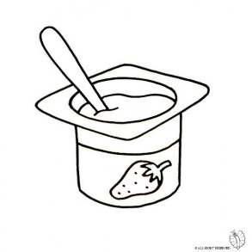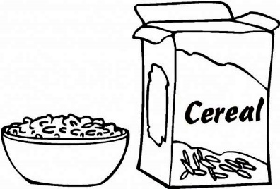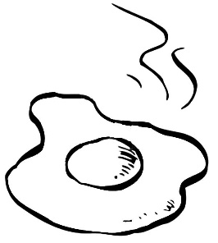

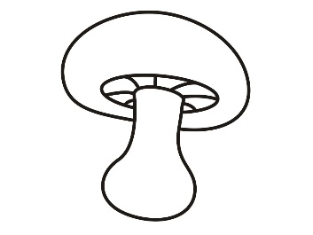

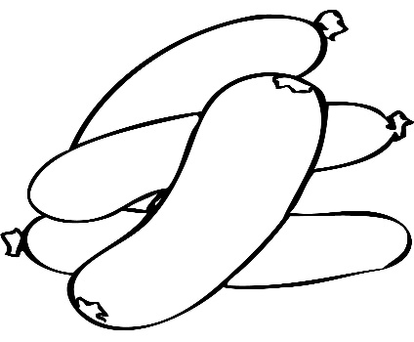

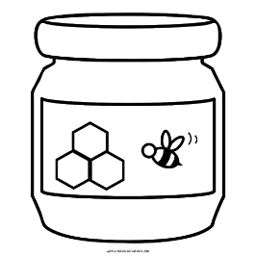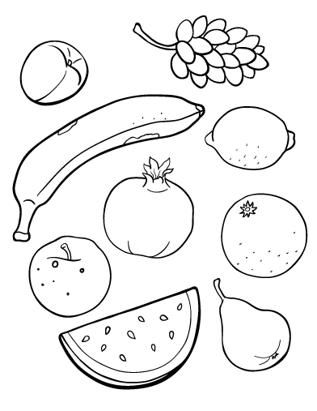



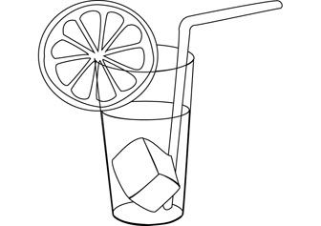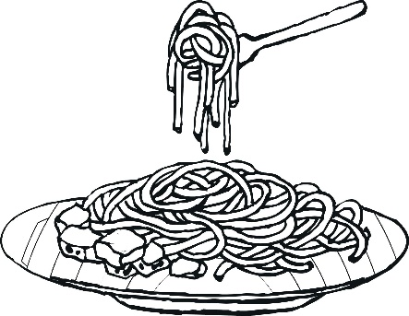

|  |  |
| --- | --- |
| **Like** | **Don’t Like** |
|  |  |
|  |  |
|  |  |
|  |  |
|  |  |
|  |  |
|  |  |