**ENGLISH WORKSHEET**

**6th   GRADE OF PRIMARY SCHOOL**

|  |  |  |  |
| --- | --- | --- | --- |
| **Student Name** |  | | **Grade:** 6th grade |
| **Date:** Week 7 |
| **Unit: 1** | *“Food and health”* | | |
| **O.A.(s):** | **OA 6** Leer comprensivamente textos no literarios, menús, recetas, para identificar vocabulario temático. | | |
| **Objective** | To classify information in order to express preferences related with food. | | |
| **Teacher:** | Constanza Caneo Zamora  **constanza.caneo@colegio-patriciomekis.cl** | **Subject:** | English |

**VOCABULARY: Classify, identify, write, describe and demonstrate.**

1. **Read and follow the instructions. ( Lee y sigue las siguientes instrucciones para desarrollar la actividad que se presenta más abajo)**

|  |
| --- |
| **INSTRUCTIONS** |
| 1. **Color the Food that are healthy.** *( Colorea la comida que es saludable)* |
| 1. **Circle the Food that you like.** *(Encierra con un círculo la comida que a ti te gusta)* |
| 1. **Put an X on the Food that are unhealthy.** *( Marca con una X la comida que no es saludable)* |

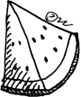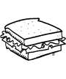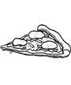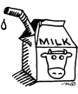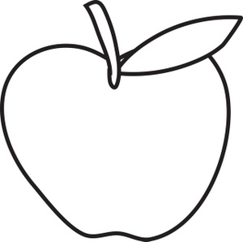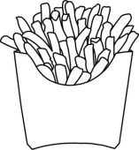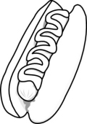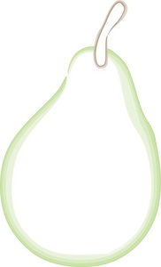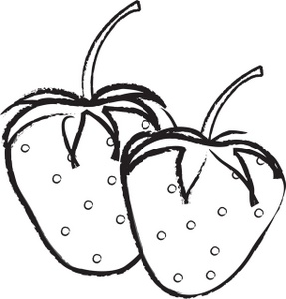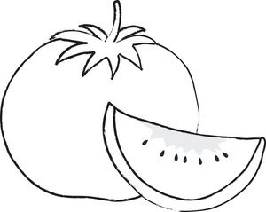

1. **Write 5 Healthy And 5 Unhealthy Food. (Escribe 5 alimentos que son saludables y**

**5 alimentos que no son saludables).**

|  |  |
| --- | --- |
| **HEALTHY (Saludable)** | **UNHEALTHY (No Saludable)** |
|  |  |
|  |  |
|  |  |
|  |  |
|  |  |

1. **Write 4 sentences expressing your preferences ( Escribe 4 oraciones, 2 expresando lo que te gusta y 2 para expresar lo que No te gusta)**

* **I LIKE ___________________________________________________________**
* **I _______________________________________________________________**
* **I DON’T LIKE ______________________________________________________**
* **I _________________________________________________________________**