**ENGLISH WORKSHEET**

**7th   GRADE OF PRIMARY SCHOOL**

|  |  |  |
| --- | --- | --- |
| **Student Name** |  | **Grade:** 7th grade |
| **Date:** _____ / _____ /2020 |
| **O.A.(s):** | **OA 13** Demostrar conocimiento y uso del vocabulario aprendido:  › vocabulario temático de uso cotidiano  › palabras de uso frecuente | |

**VOCABULARY: Remember, identify, write, and match.**

1. 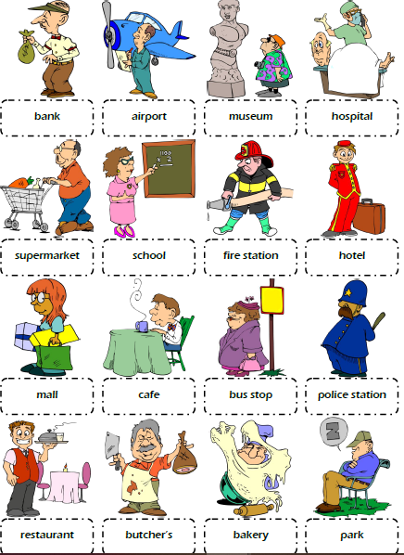
2. **Write the missing letters in the boxes to complete the places of the city vocabulary. *( Escribe la letra que falta para completar las palabras)***

