**HOMEWORK**

**7th   GRADE OF PRIMARY SCHOOL**

|  |  |  |  |
| --- | --- | --- | --- |
| **Student Name** |  | | **Grade:** 7th grade |
| **Date:** Week 6 |
| **Unit: 1** | *“Feelings and Opinions”* | | |
| **O.A.(s):** | **OA 9** Demostrar comprensión de ideas generales e información explícita en textos simples para identificar las emociones. | | |
| **Objective** | To identify the use of verb to be in order to express emotions. | | |
| **Teacher:** | Constanza Caneo Zamora  **constanza.caneo@colegio-patriciomekis.cl** | **Subject:** | English |

**What did we learn today?**

**¿Qué aprendimos hoy?**



**Choose the correct option (Marca la alternativa correcta)**

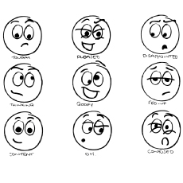

**Solucionario Guía de trabajo (Archivo 2)**

1. **Unscramble the following sentences.**
2. **I am happy**
3. **You are say**
4. **She is angry**
5. **I am surprised**
6. **She is bored**
7. **We are scared**
8. **They are tired**
9. **He is nervous**
10. **Match the personal pronouns with the correct use of verb to be.**

|  |  |  |
| --- | --- | --- |
| **AM** | **ARE** | **IS** |
| **I** | **YOU – WE – THEY** | **SHE – HE – IT** |

1. **Find the mistakes and correct them.**

|  |  |
| --- | --- |
| I **are** ten. | I **AM** ten. |
| You **is** good at volleyball | You **ARE** good a volleyball. |
| She **am** a student. | She I**S** a student. |
| They **am** hungry. | They **ARE** hungry. |
| We **is** excited. | We **ARE** excited. |
| I **is** from Chile. | I **AM** from Chile. |
| You **am** tired. | You **ARE** tired. |