**ENGLISH WORKSHEET**

**7th   GRADE OF PRIMARY SCHOOL**

|  |  |  |  |
| --- | --- | --- | --- |
| **Student Name** |  | | **Grade:** 7th grade |
| **Date:** Week 8 |
| **Unit: 1** | *“Feelings and Opinions”* | | |
| **O.A.(s):** | **OA 11** Demostrar comprensión de textos literarios al identificar: Palabras y frases clave, expresiones de uso frecuente, vocabulario temático. | | |
| **Objective** | To learn vocabulary related to hobbies and free time activities. | | |
| **Teacher:** | Constanza Caneo Zamora  **constanza.caneo@colegio-patriciomekis.cl** | **Subject:** | English |

**VOCABULARY: Read, identify, write, and understand.**

**Hobbies and Free Time Activities Vocabulary**

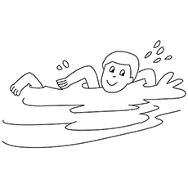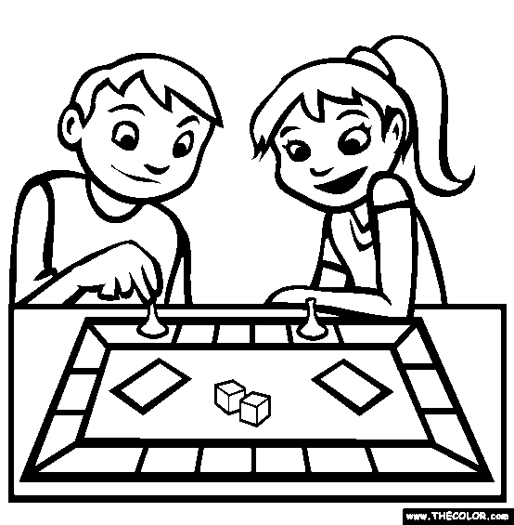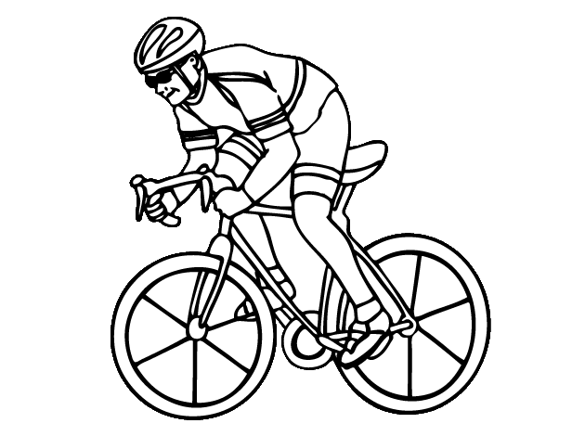

**CYCLING SWIMMING PLAY BOARD GAMES**

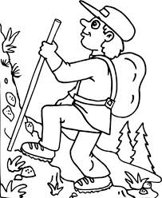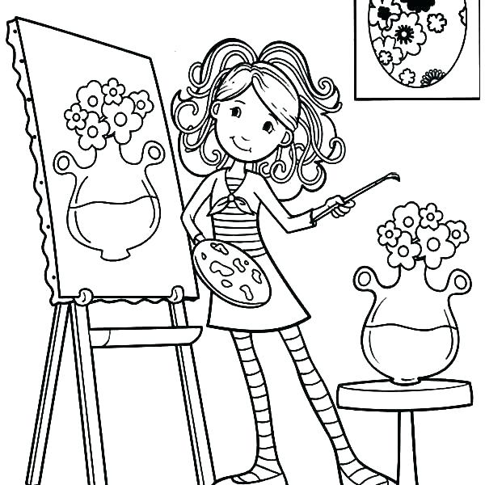

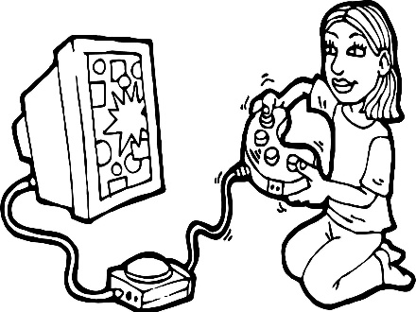

**PLAY VIDEO GAMES PAINTING TREKKING**

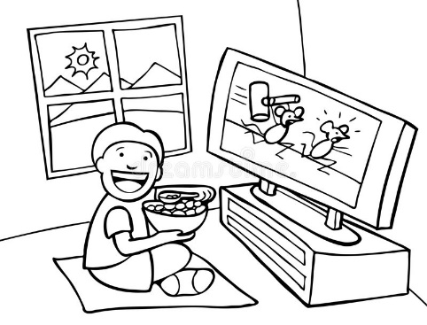

**WATCH TV LISTEN TO MUSIC TAKE PICTURES**



**CHAT WITH FRIENDS GO SHOPPING**



**Remember (Recuerda)**

* **Cycling /saicling/ =** Andar en bicicleta
* **Swimming /suiming/ =** Nadar
* **Play board games / plei bord gueims/ =** Jugar juegos de mesa.
* **Play video games /plei video gueims/** = Jugar video juegos.
* **Painting / peinting/ =** Pintar
* **Trekking =** Hacer excursionismo
* **Watch TV =** Ver televisión
* **Listen to music /lisen tu miusic/ =** Escuchar música
* **Take pictures** = Fotografiar
* **Chat with friends = Chatear con amigos**
* **Go shopping =** Ir de compras