**ENGLISH WORKSHEET**

**8th   GRADE OF PRIMARY SCHOOL**

|  |  |  |
| --- | --- | --- |
| **Student Name** |  | **Grade:** 8th grade |
| **Date:** _____ / _____ /2020 |
| **O.A.(s):** | **OA 13** Demostrar conocimiento y uso del vocabulario aprendido:  › vocabulario temático de uso cotidiano  › palabras de uso frecuente | |

**VOCABULARY: Remember, identify, write, and match.**

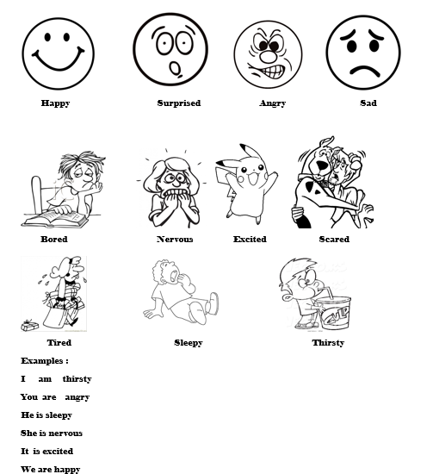

Emotions and Feelings Worksheet

1. Write the name of the following emotions.

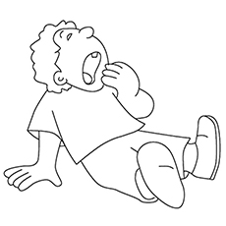  

__________________ _________________ _____________ _________________

1. Match the following emotions.



Sad

 Happy

 Thirsty

Excited

1. Write the missing letter

1. T__R__D 5. S__AR__D 9. A__G__Y

2. S__D 6. E__C__T__D 10. S__R__R__SE__

3 . H__P__Y 7. N__RV__U__ 11. T__IR__T__

4. S__E__P__ 8. B__R__D

**Scared**

**Happy**

**Excited**

**Nervous**

**Tired**

**Sad**

**Bored**

**Sleepy**

IV . Find and circle the emotions in the word search puzzle below.

|  |  |  |  |  |  |  |  |  |  |
| --- | --- | --- | --- | --- | --- | --- | --- | --- | --- |
| A | N | E | R | V | O | U | S | P | T |
| E | C | X | A | D | C | B | A | L | K |
| X | N | M | P | R | Q | X | D | B | S |
| C | Z | W | S | C | G | V | T | O | C |
| I | X | S | L | E | E | P | Y | R | A |
| T | W | T | B | W | Q | F | I | E | R |
| E | H | A | P | P´ | Y | S | U | D | E |
| D | Z | Y | G | R | T | S | A | I | D |
| O | H | N | T | I | R | E | D | K | P |
| I | J | B | Q | X | L | B | S | O | U |