**ENGLISH WORKSHEET**

**8th   GRADE OF PRIMARY SCHOOL**

|  |  |  |  |
| --- | --- | --- | --- |
| **Student Name** |  | | **Grade:** 8th grade |
| **Date:** Week 7 |
| **Unit: 1** | *“Information and Communication Technologies”* | | |
| **O.A.(s):** | **OA 15** Escribir para expresar opiniones y usando: Palabras, oraciones y estructuras aprendidas y otras de uso frecuente. | | |
| **Objective** | To express preferences with the use of some expressions such as like, enjoy, hate, don’t mind. | | |
| **Teacher:** | Constanza Caneo Zamora  **constanza.caneo@colegio-patriciomekis.cl** | **Subject:** | English |

**VOCABULARY: Classify, identify, write, and describe.**

1. **Look at the pictures and match the word with the correct picture. ( Mira las imágenes y une la palabra con la imagen correcta)**

|  |  |  |
| --- | --- | --- |
| **Hate** | **Like** | **Don’t mind** |
| **Enjoy** | **Don´t like** | **Love** |



1. **Look at the graphic and use the expression in it to create sentences saying how much you like doing the activities below*. (Mira el gráfico para crear oraciones expresando cuanto te gusta realizar las actividades que se presentan más abajo)***

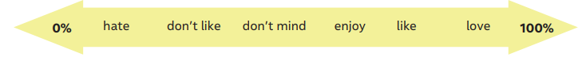

* A continuación te presentaré un ejemplo para que realices las actividades que se presentan más abajo.

* ***Taking pictures (fotografiar): I enjoy taking pictures.***

1. **Text messaging**: _______________________________________________________
2. **Posting on social media:** _________________________________________________
3. **Watching videos:** ________________________________________________________
4. **Playing video games:** _______________________________________________________
5. **Listening to music:** _________________________________________________________