**ENGLISH WORKSHEET**

**5th   GRADE OF PRIMARY SCHOOL**

|  |  |  |  |
| --- | --- | --- | --- |
| **Student Name** |  | | **Grade:** 5th grade |
| **Date:** Week 8 |
| **Unit: 1** | *“My World”* | | |
| **O.A.(s):** | **OA 13** Demostrar conocimiento y uso del vocabulario aprendido: vocabulario temático de uso cotidiano. | | |
| **Objective** | To learn vocabulary related to parts of the school. | | |
| **Teacher:** | Constanza Caneo Zamora  **constanza.caneo@colegio-patriciomekis.cl** | **Subject:** | English |

**VOCABULARY: Recognize, identify, write, and demonstrate.**

**Parts of the School Vocabulary**

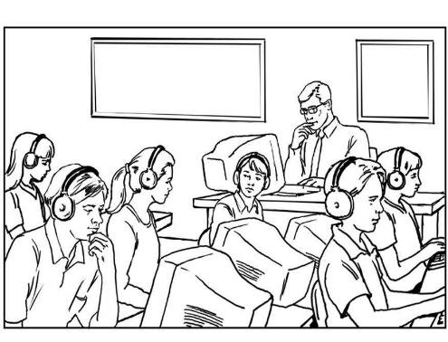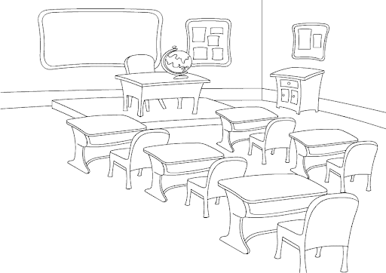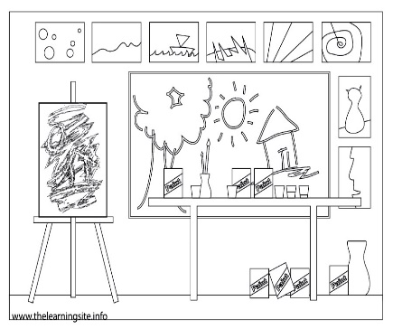

**CLASSROOM ART ROOM COMPUTER ROOM**

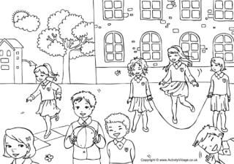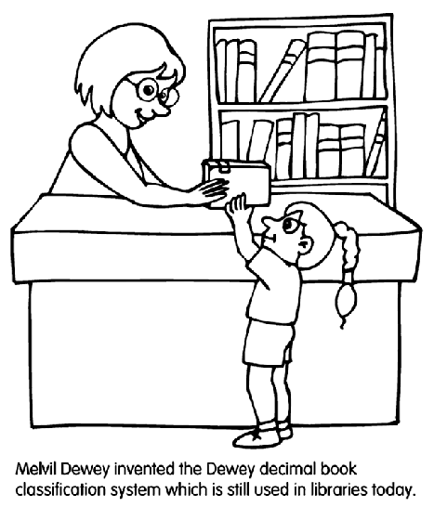



**RESTROOM LIBRARY SCHOOLYARD**

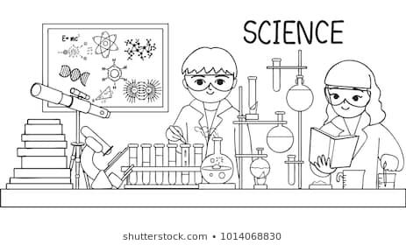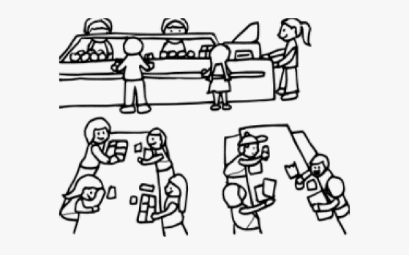

**PRINCIPAL’S OFFICE CAFETERIA LAB**

**Remember (Recuerda)**

* **Classroom /clasrum/** = Sala
* **Art room /art rum/** = Sala de arte
* **Computer room /** computer rum/ = Sala de Computación
* **Restroom /restrum/ =** Baño
* **Library / laibrary/ =** Biblioteca
* **Schoolyard /sculyard/ =** Patio
* **Principal’s office =** Oficina del director.
* **Cafeteria =** Comedor
* **Lab = Laboratorio**



**Nota:** Para complementar el aprendizaje de su hijo, usted puede ingresar al siguiente link:

<https://www.youtube.com/watch?v=sDFe1q2a7sk>

