**HOMEWORK**

**5th   GRADE OF PRIMARY SCHOOL**

|  |  |  |  |
| --- | --- | --- | --- |
| **Student Name** |  | | **Grade:** 5th grade |
| **Date:** Week 8 |
| **Unit: 1** | *“My World”* | | |
| **O.A.(s):** | **OA 13** Demostrar conocimiento y uso del vocabulario aprendido: vocabulario temático de uso cotidiano. | | |
| **Objective** | To learn vocabulary related to parts of the school. | | |
| **Teacher:** | Constanza Caneo Zamora  **constanza.caneo@colegio-patriciomekis.cl** | **Subject:** | English |

1. 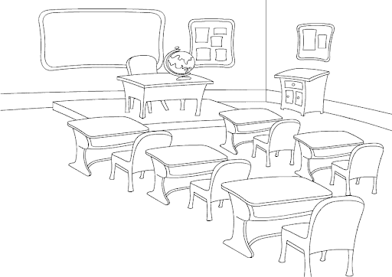**Look at the picture and write the name of the following parts of the school.**

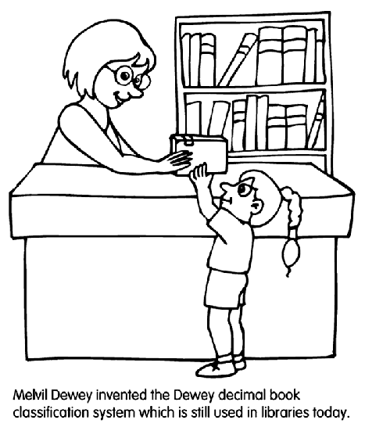

________________ ___________________ _______________ ________________

1. **Complete with the missing letter. (Completa con la letra que falta para formar la palabra)**
2. **CL__SSR__OM**
3. **A__T R__OM**
4. **C__MPUT__R R__OM**
5. **R__STR__OM**
6. **L__BR__R__**
7. **PR__NC__PAL OFF__C__**
8. **SCH__O__YA__D**