**HOMEWORK**

**6th   GRADE OF PRIMARY SCHOOL**

|  |  |  |  |
| --- | --- | --- | --- |
| **Student Name** |  | | **Grade:** 6th grade |
| **Date:** Week 8 |
| **Unit: 1** | *“Food and health”* | | |
| **O.A.(s):** | **OA 6** Leer comprensivamente textos no literarios, menús, recetas, para identificar vocabulario temático. | | |
| **Objective** | To distinguish food vocabulary in some texts. | | |
| **Teacher:** | Constanza Caneo Zamora  **constanza.caneo@colegio-patriciomekis.cl** | **Subject:** | English |

1. **Think about a typical Chilean dish and make a list of the main ingredients below. (Piensa en un plato típico chileno y escribe el nombre del plato y luego los ingredientes de este).**

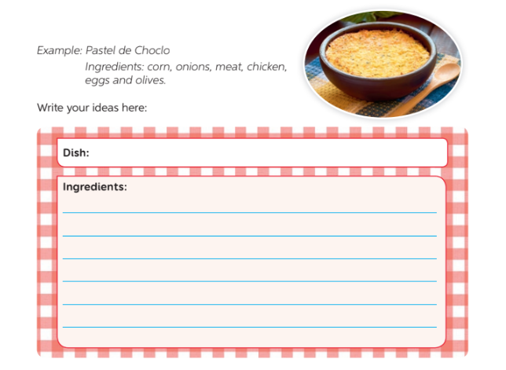

**Solucionario (Archivo 2)**

1. **Look at these meals. Classify them into breakfast, lunch and dinner.**

|  |  |  |
| --- | --- | --- |
| **Breakfast** | **Lunch** | **Dinner** |
| A bowl of cereal and apple. | Lasagna and salad | A fried egg and a sausage. |
| Cheese sandwich, chocolate cookies and tea. | Roasted chicken and French fries. | Avocado and tomato with a glass of water. |

1. **Read the short paragraph and write in the chart all the ingredients that you find.**

* **Beans**
* **Onions**
* **Garlic**
* **Meat**
* **Tomatoes**
* **Avocado**

1. **Posible respuesta: My favorite food is Chicken with French fries.**